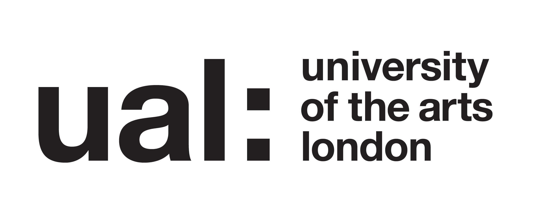

Research project: Understanding the awareness of Cosmetic Science students of UAL’s Counselling, Health Advice and Chaplaincy services

Participant Information Sheet

About this study

This study is part of my research on the PgCert Academic Practice in Art, Design and Communication at UAL.

I am conducting an enquiry into the awareness of Cosmetic Science students of UAL’s Counselling, Health Advice and Chaplaincy services. I am interested in the experience of UAL students around information, communication, and referral routes to these Services.

My enquiry will explore students’ awareness about UAL’s Counselling, Health Advice and Chaplaincy services. The study will use qualitative methods that will consist of a structured survey which you will be asked to complete based on your experience. Responses will be analysed using thematic analysis, to understand the experience and needs of our student population.

What does it mean to take part?

If you take part you are consenting to taking part in a structured qualitative survey. The survey is designed to take up to 15 minutes for its completion, however you may take as much as possible to adequately express your experience. Your responses will be digitally recorded, anonymised and placed within the general collected data so that they can be analysed and eventually disseminated into a report. The data will be used as the basis for academic analysis.
If you choose to take part, you will be free to withdraw your participation at any point, until you have submitted your responses. You can close the form and will not be obliged to give any reason for deciding not to take part.

Will my participation be kept confidential?

Your anonymity is very important. The information about you will be confidential to me, as the researcher. You will not be identified individually anywhere in the research. If I quote anything you have said in the survey, it will be anonymous. An example might be: ‘Student A said ‘The project is…’.’

This information will not be used outside for this research enquiry and will not affect your academic record in any conceivable way, including sharing with other university lecturers.

What will happen to the results of the research project?

Analysis from the qualitative survey, including quotations from you, will contribute to an academic dissertation. The hope is to eventually summarise your shared experience into a coherent academic report, which will be used to improve the overall course. Your words may also be used in academic reports, papers or presentations. These may appear online.

Thank you for your contribution and participation in this study.

Contact for further information:
Maria Charalampous, Investigator
m.charalampous@fashion.arts.ac.uk

